2019,2020,2021,2022 – Benefits

Most of these are self-explanatory, Car and Van benefits will be the top box, and Car and Van fuel will be the second box. Please make sure you are getting the P11D figures or the figures from HMRCs final calculation for all benefits.
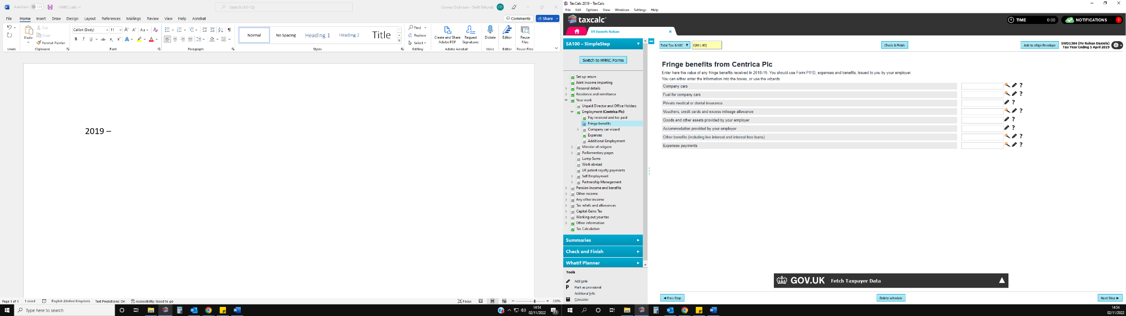
Private medical and dental insurance will be the 3rd box – this is one of the most common benefits received

This may be described by HMRC as an asset transfer

HMRC will describe this as taxable expense payments

This will usually be described as “employers benefits” or “employment benefits” or a “benefit in kind”

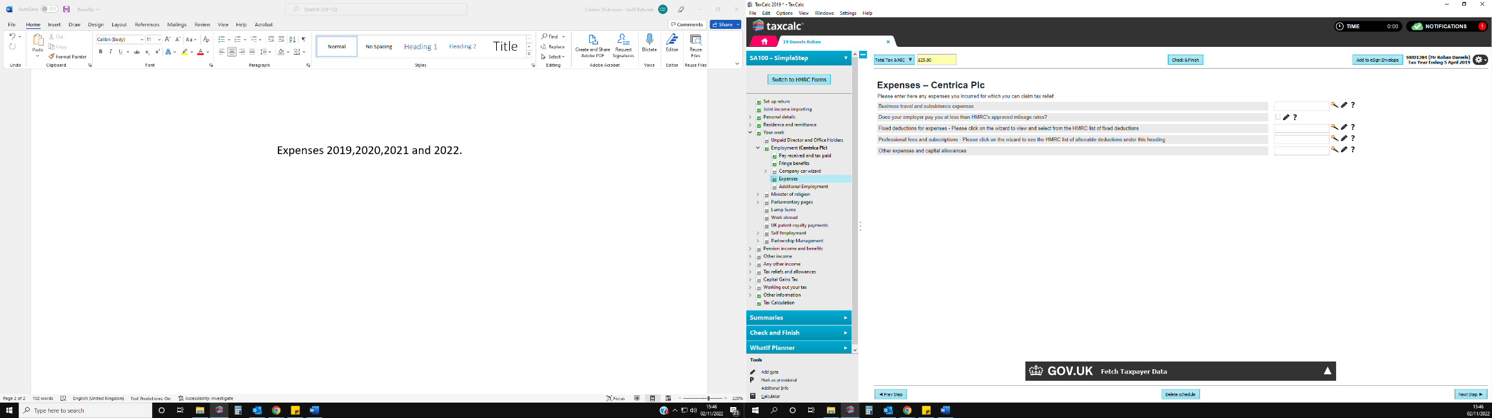
Expenses 2019,2020,2021,2022

,

Flat rate expenses already included in code
Professional subscriptions

Job expenses

- If the job expenses are in the tax code do not add these to the expenses, we have calculated on the spreadsheet
- Flat rate expenses usually go up in £20 instalments from £60 to £140 – if these are in the code remove laundry from our expenses on the spreadhseet
- If there are professional subscriptions in the tax code and the client has stated professional subscriptions on their expenses claim, please check they are not for the same thing.

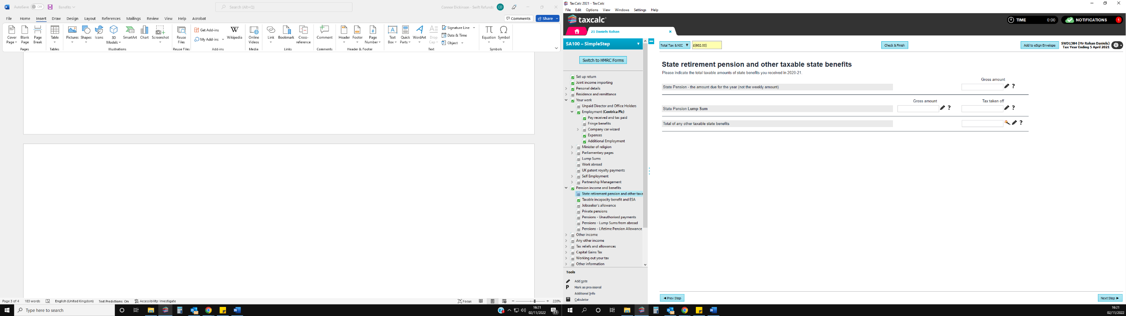
State pension 2019,2020,2021 and 2022
State pension is the same in Tax Calc for each tax year, the deduction from the tax code will go in the top box.
Tax Reliefs and Allowances –

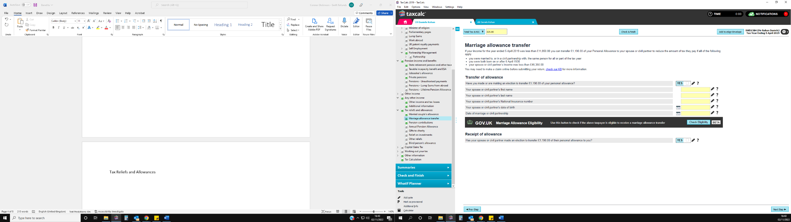
- Marriage allowance transfer for all 4 years.
If HMRC inform you the client has transferred 10% of there allowance to their partner you will select this box, however if this is the case, we will need further details from the client such as the date of the marriage, the clients partners first and last name, the clients partners national insurance number, the clients partners date of birth.
If HMRC inform you the client has received marriage allowance from there partner, you will select this box. This will carry forward on tax calc each year so if the marriage allowance stops you will need to untick it

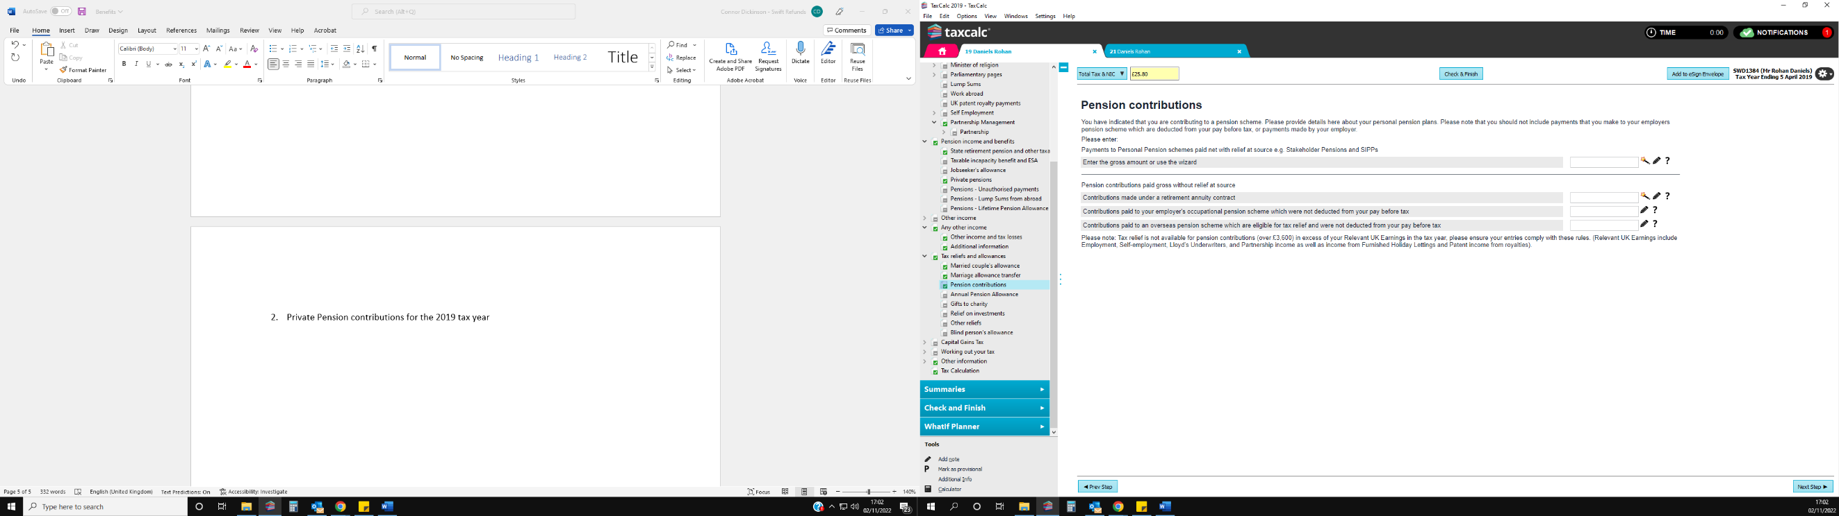
- Private pension contributions for the 2019 tax year
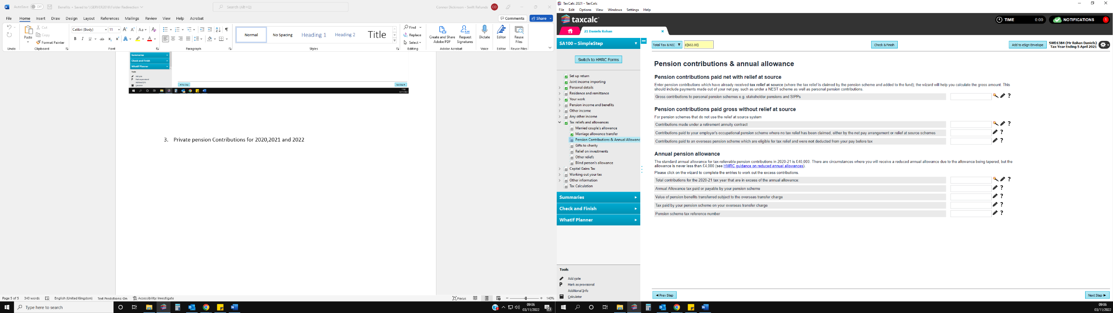
Private pension Contributions for 2020,2021 and 202
HMRC will describe these as private pension payments, we only usually use the first and second box.

Underpayments, overpayments, and adjustments.
HMRC will describe these as private pension payments, we only usually use the first and second box.

This looks slightly different for the 2019 tax year in tax calc than it does for the 2020,2021 and 2022 tax years. For all the years you will need to ask HMRC and then the client if HMRC do not know if the pension payments are paid with or without relief at the source, if they have relief at the source the amount will go in the top box and if there is no relief at the source the amount will go in the second box.

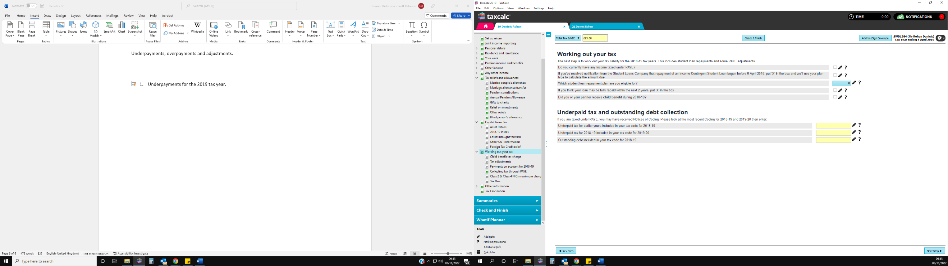
- Underpayments for the 2019 tax year.
Advisory –
For the 2019 tax year clients are often underpaid by around £47 due to the year having 53 tax weeks – if this is the case, we can just add our expenses on.

HMRC will describe this as an outstanding debt restriction in the tax code. The full amount will go in the box
If you have entered all the information given by HMRC and the client shows as underpaid for the year, ask HMRC if on their calculation the client is underpaid for the tax year, if they say yes and give you a figure it will go in this box.
When we call for the tax code breakdown for 2019, if HMRC advise there is a deduction for an underpayment the figure given will go in this box
enter any figures.
If HMRC say there is a deduction of … to collect … we will use the collected figure.
For example, if HMRC say there is a deduction in the tax code of £1000 to collect £200 it is the £200 that will go in this box

For the 2019 tax year, if there are any underpayments collected in the tax code or any underpayments carried forward from the tax year this top box will need to be selected in order to be able to enter any figures in the boxes below

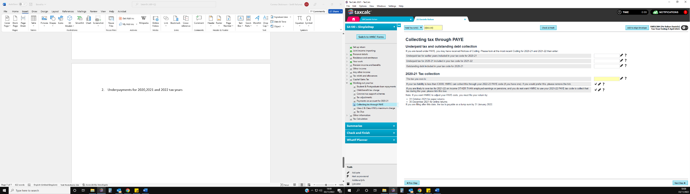
Underpayments for 2020,2021 and 2022

If you have entered all the information given by HMRC and the client shows as underpaid for the year, ask HMRC if on their calculation the client is underpaid for the tax year, if they say yes and give you a figure it will go in this box.

HMRC will describe this as an outstanding debt restriction in the tax code. The full amount will go in the box

When we call for the tax code breakdown for 2020,2021 and 2022, if HMRC advise there is a deduction for an underpayment the figure given will go in this box.
If HMRC say there is a deduction of … to collect … we will use the collected figure.
For example, if HMRC say there is a deduction in the tax code of £1000 to collect £200 it is the £200 that will go in this box

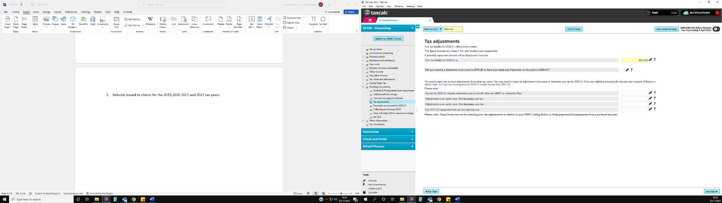
- Refunds issued to clients for the 2019,2020 2021 and 2022 tax years.

The refunds issued to client section can be found in the tax adjustments section for all 4 tax years
If you have entered all the information given by HMRC that is in the client’s tax code and all P11Ds benefits etc and the clients tax year still shows as overpaid, ask HMRC if the client was overpaid on their calculation, if they were ask if the client was refunded – any refunds issued will go in the top box.

